Our Cookie Policy

As Barair Hava Taşımacılık ve Operasyon Hizmetleri A.Ş., we use cookies to make the most efficient use of our websites and to improve your user experience. If you do not prefer to use cookies, you can delete or block cookies from your browser settings or from the detailed cookie removal description below. However, we would like to remind you that this may affect your use of our websites. We will assume you agree to the use of cookies on our websites unless you change your cookie settings in your browser. You can access the regulations on the data collected from the Clarification Text on our websites.

Our cookies are used to provide you with an individualized experience, to improve our services and optimize your experience when using our websites.

Cookies can be evaluated under different headings according to their purpose and forms of use. Some of these headings are explained below;

Session cookies: These are temporary cookies, deleted when you close your browser, so they are not persistent. These are used for purposes such as ensuring security and continuity for you and our websites during your visits.

Persistent cookies: These cookies remain in your browser’s sub-folders until they are either removed by your action or the time range within the cookie expires. These cookies help our website remember your information and choices in your future visits.
First and third-party cookies: First-party cookies are cookies used by our website. Third-party cookies are cookies installed on your computer other than our website.

Mandatory cookies: These are cookies of anonymous nature that are installed to ensure the http://www.barair.com.tr/ websites function and offer their features properly.

Functional and analytical cookies: Functional cookies are used to remember your preferences and help us improve your browsing experience, and analytical cookies are used to allow us see which of our pages attract more attention, which resources are viewed most, and enable us to view the traffic on our websites and offer services in line with the traffic. Cookies of this nature are also anonymous.

Session cookies, mandatory cookies, persistent cookies as well as functional and analytical cookies are used on website and/or websites or mobile web of Barair Hava Taşımacılık ve Operasyon Hizmetleri A.Ş.

The cookies other than mandatory and first-party cookies used by our websites are:

Google: Google cookies can be used for many purposes. For example, they are used to remember your safe search preferences, show you more relevant ads, determine how many visitors come to a page, help you use and sign up for services offered by Google, protect your data, or remember your ad settings.

Google Tag Manager: These cookies will enable us to analyse your use of the website by assigning a unique and randomly generated ID to your device, which will allow us to recognize you on your next visit. Your information is sent to Google by your browser and processed by Google.

The user can remove persistent cookies and reject both session cookies and persistent cookies by following the instructions given in the “help” file of their internet browser or by visiting “www.allaboutcookies.org” or “www.youronlinechoices.eu”. If the user rejects permanent cookies or session cookies, they can continue to use the said website or mobile web but may not be able to access all functions of the said media or their access may be limited.

How to delete cookies?

Most cookies are easy to delete. Simply select your browser and follow the instructions.
​
​

Chrome
- Press the Ctrl + Shift + Delete keys on your keyboard.
- Select a time range.
- Select the ‘Cookies and other site data’ checkbox.
- Click on “Clear data” button.

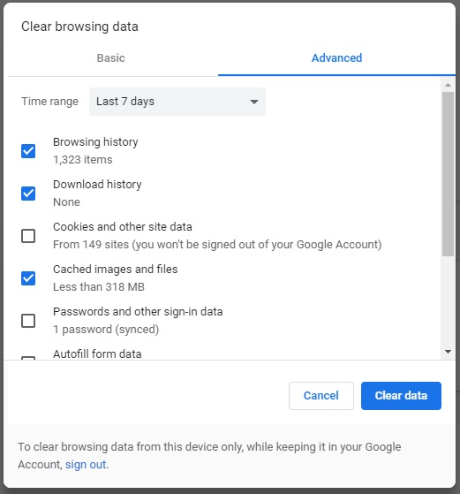

Firefox
- Press the Ctrl + Shift + Delete keys on your keyboard.
- Select a time range to clear.
- Select the ‘Cookies’ checkbox.
- Click on “Clear Now” button.

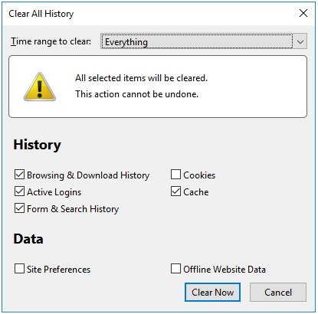

Safari
- Select Preferences on the Safari menu.
- Go to the Privacy tab.
- Click on ‘Manage website data’.
- Click on ‘Remove All’.

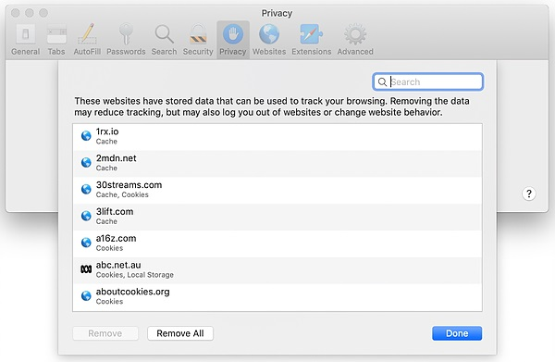

Edge
- Press the Ctrl + Shift + Delete keys on your keyboard.
- Select the ‘Cookies and saved website data’ checkbox.
- Click on “Clear” button.

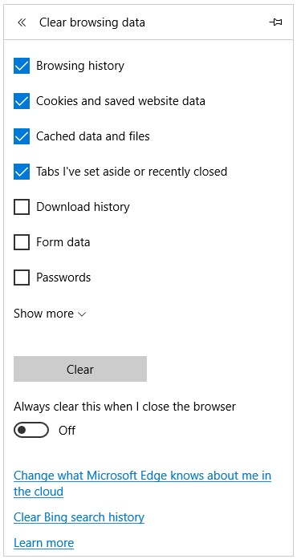

Internet Explorer
- Press the Ctrl + Shift + Delete keys on your keyboard.
- Select the ‘Cookies and website data’ checkbox.
- Click on “Delete” button.

